# Deploying mechanical turk jobs using the windows batch files:

1. Rename the files LoadHITBatchExpt2Set1_prod.txt to LoadHITBatchExpt2Set1_prod.cmd
2. The file is now a windows executable.
3. Double click on the file to run the file.
4. Follow the instructions below

The batch file will prompt for

**"Enter source drive : "**

Please enter the source drive in which your amazon command line tools are installed, for me aws-clt was installed in C. No colons needed.

The next prompt is;

**"Enter AWS CLT bin directory path : "**

Enter the full path of aws clt bin directory.

Example : C:/<aws-clt installation directory>/bin

The next prompt is

**"Enter jobs directory path : "**

Enter the full path of the folder where you see all 100 .input and .question files.

Example: C:/Sreejith/<some-path>/prod

Below is a snapshot of the execution from my VM.

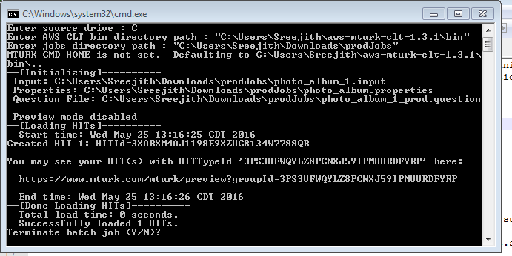

# Approval and downloading the results

The format of the result file has been changed and it is no longer a csv file. Please make sure that we preserve the .success files that are created in after running the createHIT batch file.

The .result file will also be created in the same folder and I would need that files to perform any sort of data analysis.

1. Rename the file ApproveWorkBatchExpt2_prod.txt to ApproveWorkBatchExpt2_prod.cmd to make it a windows executable.
2. Double click on the file to run the file.
3. You will see prompts similar to jobs deployment. Follow the steps above to approve all the work.
4. Follow steps 1 through 3 for GetResultsBatchExpt2_prod.txt